**THE TRAGEDY OF FLIGHT : A COMPRHENSIVE CLASH ANALYSIS**

An airplane crash analysis is a detailed investigation into the causes of an aviation accident. The goal of an airplane crash analysis is to identify any factors that contributed to the accident, with the ultimate goal of improving safety and preventing future accidents. The process of conducting an airplane crash analysis typically involves the collection and analysis of a wide range of data, including information about the aircraft and its systems, the operators, and any other relevant factors. This data is typically collected from Kaggle. Once the data has been collected, it is analysed through tableau, to identify any potential causes of the accident. The results of an airplane crash analysis are typically published in a report, which may include recommendations for improving safety and preventing similar accidents in the future. These recommendations may be implemented by the relevant authorities or industry organizations.

**1.1 OVERVIEW**

Piloting an aircraft requires lengthy training, a knowledge of the mechanical components of an aircraft, and hand-eye coordination skills to effectively and safely maneuver an aircraft. Pilots also have to think ahead. Planning flights, checking the weather, and anticipating changes are all keys to being a safe pilot. If a pilot doesn’t plan the flight properly, gets into bad weather, or doesn’t anticipate issues then airplane crashes can happen. Occasionally pilots become disoriented, especially while operating in clouds, under Instrument Flight Rules (IFR). Pilot disorientation can lead to stalls or spins that lead to crashes. Having an attorney that understands piloting is important if legal action is needed.

**PROBLEM DEFINITION AND DESIGN THINKING**

**2.1 EMPATHY MAP**

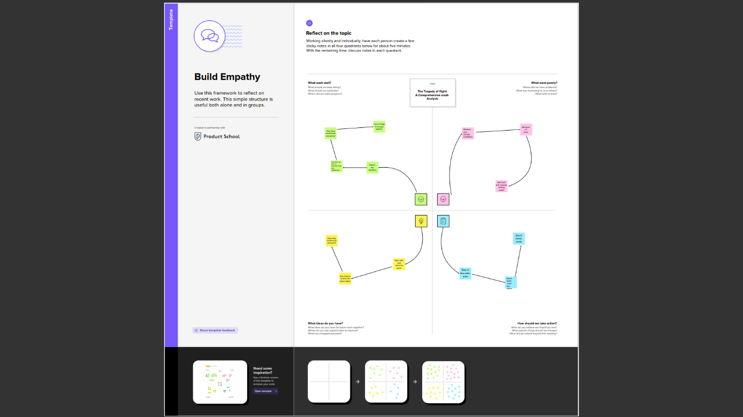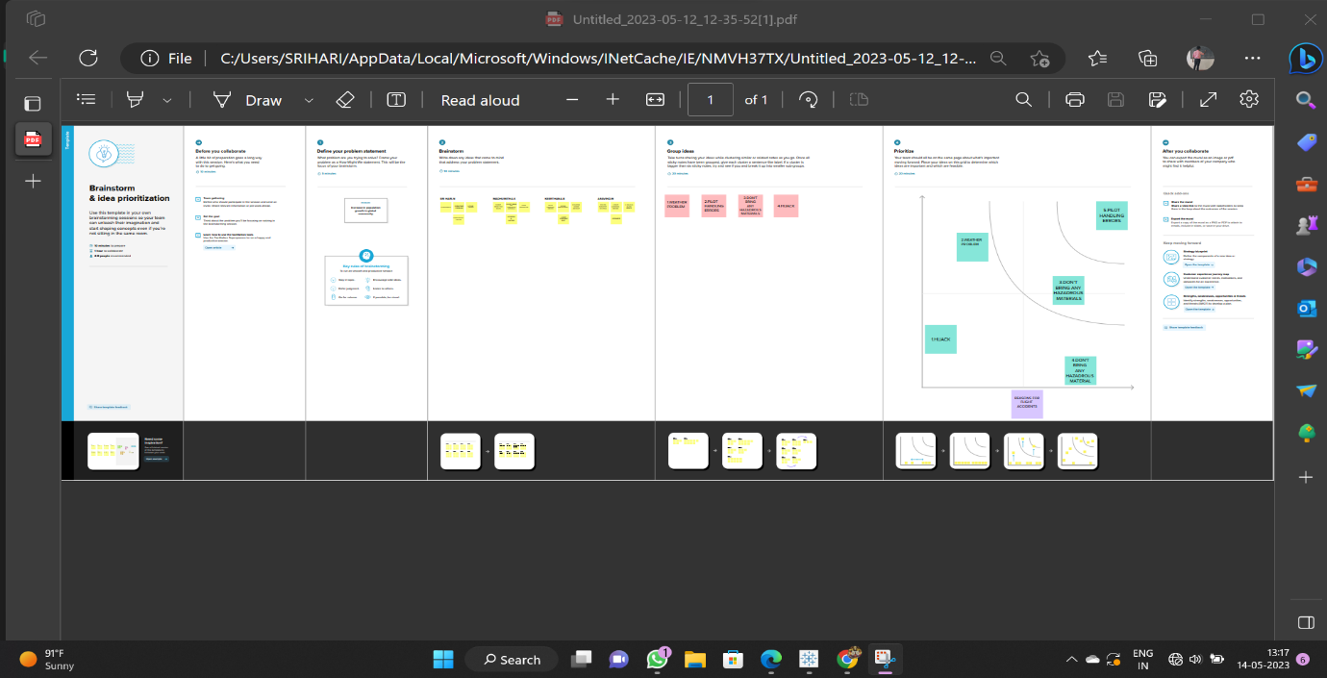

**2.2 BRAIN STORMING**

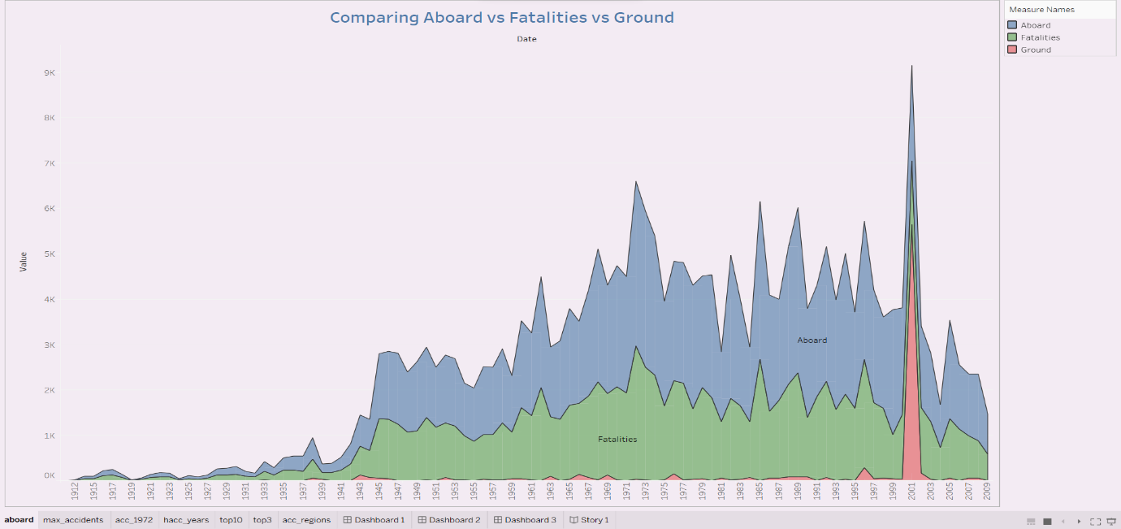

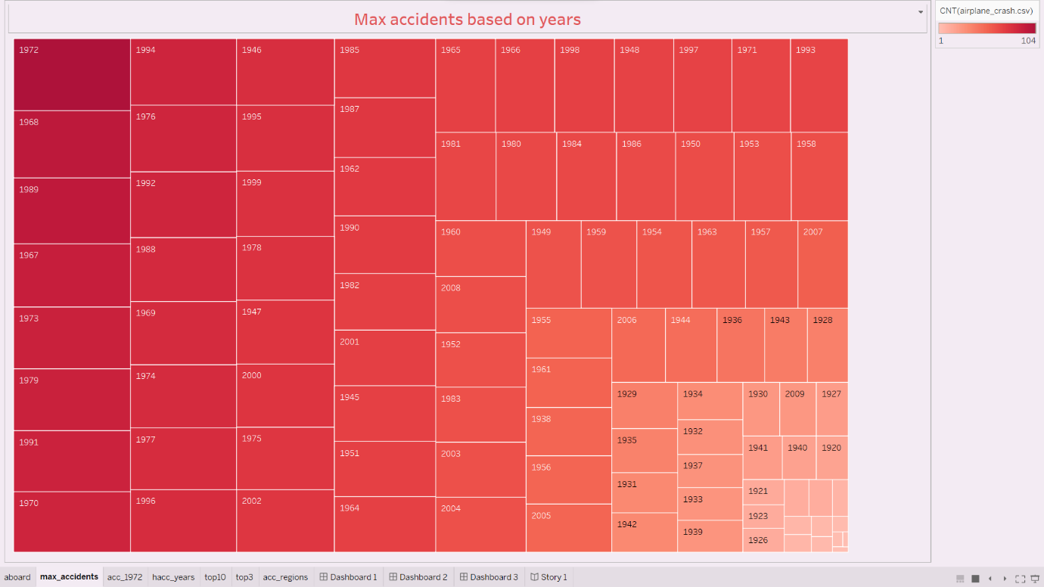

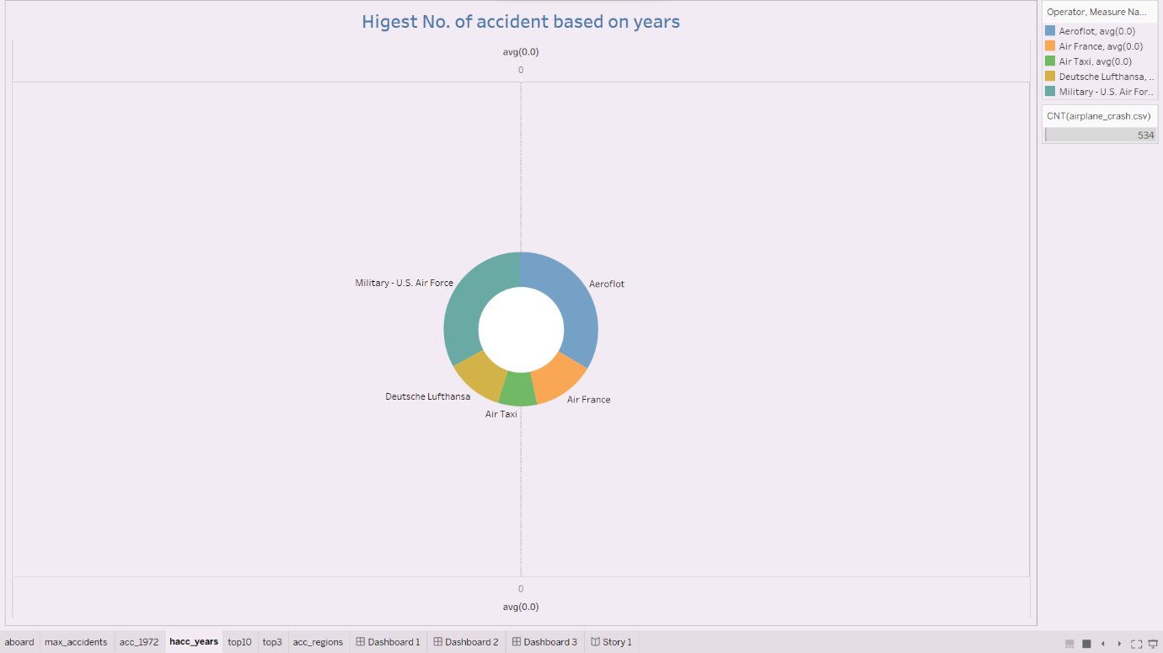

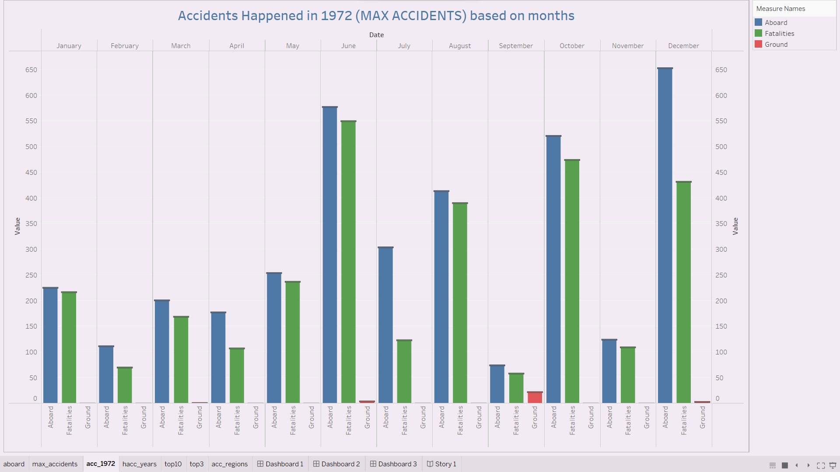

**DASHBOARD 1**

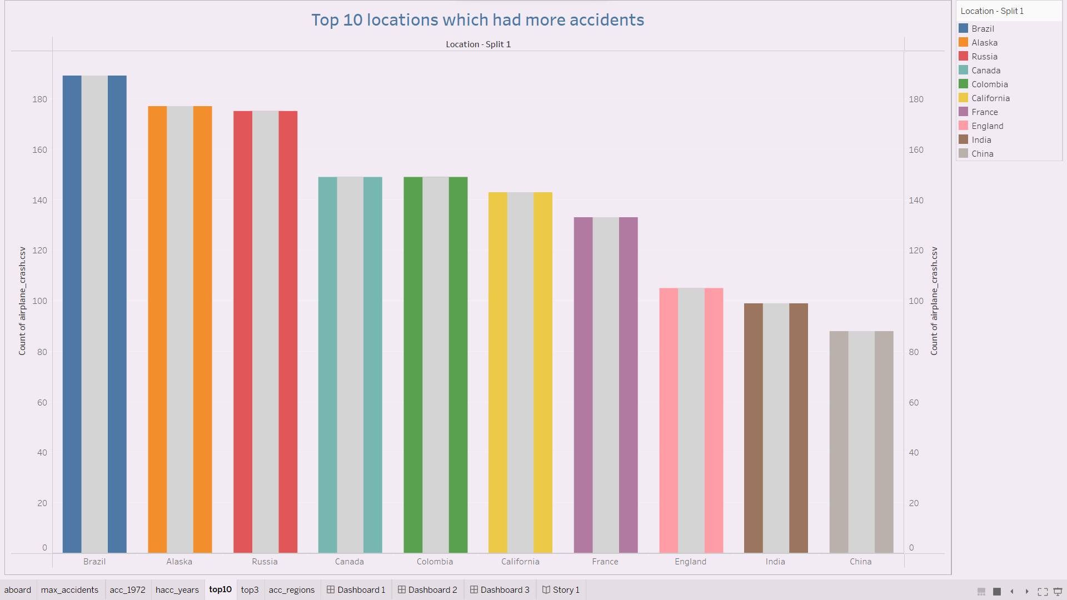

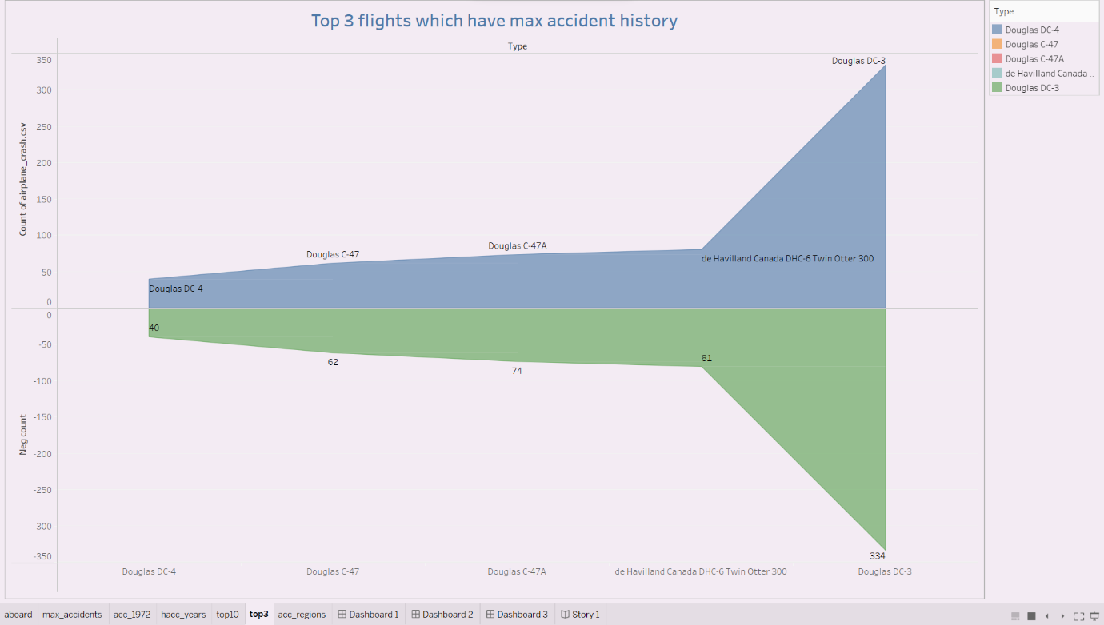

**DASHBOARD 2**

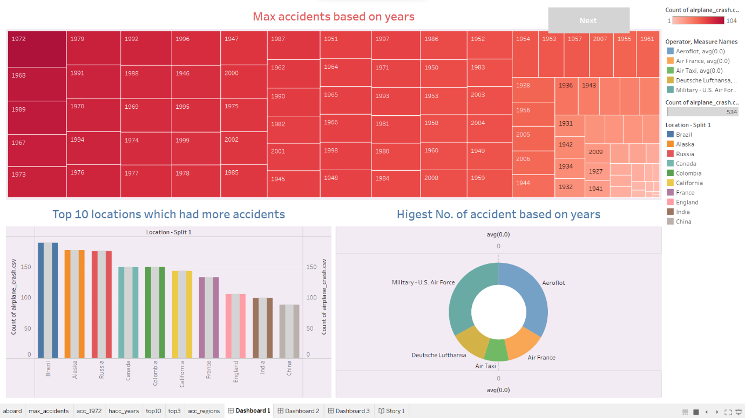

**DASHBOARD -3**

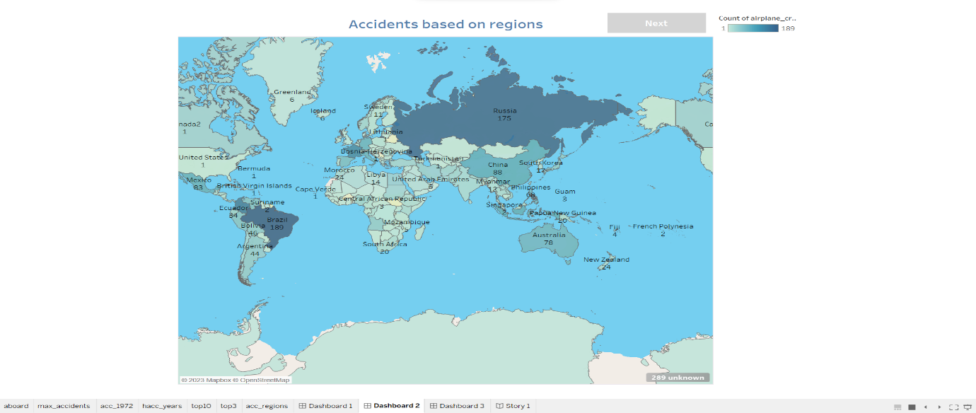

**DASHBOARD 4**

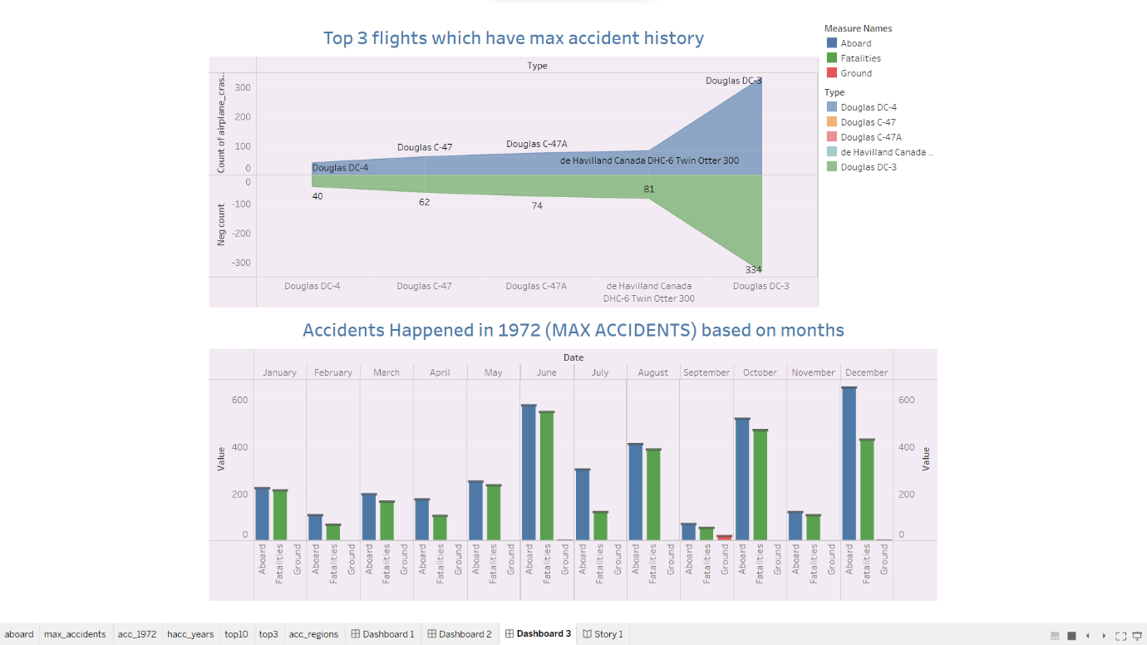

**CONCLUSION**

There are many airplane accidents a year. On an average, 70 –80% are human error. Though there are many other factors, such as design factors, management, and weather factors, human error is the largest. Each one of these factors played a certain role in the three articles of accidents. The BOAC Comet, the PSA crashes in San Diego, and the Air Florida crash in Washington D.C., were analyzed differently, taking into consideration each possible factor. Within the follow, each accident will be discussed.